|  |  |  |  |  |  |  |  |  |
| --- | --- | --- | --- | --- | --- | --- | --- | --- |
| Index | Domain size | Grid | Particle density: Pcs/m2 | | | Flux: pcs/m2.s | | |
| FCS X | FCS Y | FCS Z | FCS X | FCS Y | FCS Z |
| 1 | 360 m x 160 m x 120 m | 2 m | 29 | 180 | 552 | 0.071 | 0.350 | 1.399 |
| 2 | 360 m x 160 m x 120 m | 1m | 18 | 100 | 722 | 0.045 | 0.196 | 1.832 |
| 3 | 360 m x 160 m x 180 m | 2 m | 16 | 224 | 585 | 0.040 | 0.436 | 1.484 |

Firebrand collection area 10 m x 10 m

Firebrand collection area 2 m x 2 m

|  |  |  |  |  |  |  |  |  |
| --- | --- | --- | --- | --- | --- | --- | --- | --- |
| Index | Domain size | Grid | Particle density: Pcs/m2 | | | Flux: pcs/m2.s | | |
| FCS X | FCS Y | FCS Z | FCS X | FCS Y | FCS Z |
| 4 | 360 m x 160 m x 120 m | 1m | 35 | 494 | 643 | 0.086 | 0.963 | 1.632 |
| 5 | 360 m x 160 m x 180 m | 2 m | 14 | 919 | 589 | 0.034 | 1.791 | 1.495 |

Experiment collection area 1.83 m2

|  |  |  |  |  |  |  |  |  |
| --- | --- | --- | --- | --- | --- | --- | --- | --- |
| Index | Domain size | Grid | Particle density: Pcs/m2 | | | Flux: pcs/m2.s | | |
| FCS X | FCS Y | FCS X | FCS X | FCS X | FCS Z |
| Exp | NA | NA | 335 | 463 | 536 | 0.824 | 0.902 | 1.361 |

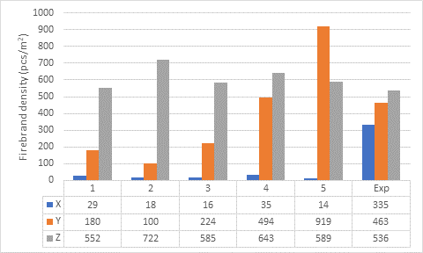

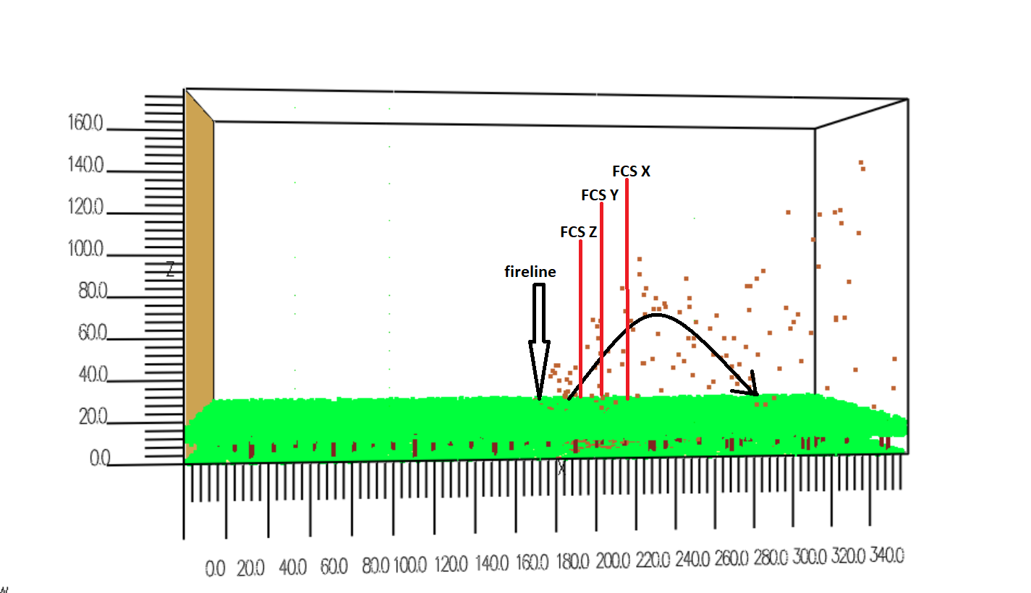

According to above results, I see it affects the grid size considerably for firebrand distribution and it is important the size of the firebrand collection device and its location.

Input number of firebrand vs fire intensity

1. Single tree burning

Average heat release rate = 5962 kW

Number of firebrand input = 350

Input number vs HRR = $\frac{input number of firebrands}{HRR}$

= $\frac{350 pcs}{5.962 MW}=58.7 pcs/MW$

Mass flux on collection pans = $\frac{18.63 g}{13 ×\left(0. 5 m ×0.3 m\right) ×40 s}=0.2388 \frac{g}{m^{2}.s}$

1. Forest burning

Average heat release rate =2401 MW (27 s to 140 s)

Fire intensity and input number of firebrands



Fireline length =130 m

Fire line depth = 2 m

Fireline intensity =18.46 MW/m



Firebrands input volume = 2m x 130 m x 9 m = 2340 m3

Input number of firebrands = 7223 pcs/s

Input number vs HRR = $\frac{input number of firebrands}{HRR}$

= $\frac{7223 pcs}{2401 MW}=3.008 pcs/MW$

Mass flux on collection pans = $\frac{1.28 ×{10}^{3}g}{3 ×100 m^{2}×104 s}=0.041 g/m^{2}$.s

|  |  |  |
| --- | --- | --- |
| simulation | Pcs vs intensity (pcs/MW) | Landing flux (in terms of mass) (g/m2. s) |
| Single tree | 58.7 | 0.2388 |
| Forest fire | 3.008 | 0.0411 |

pcs/MW

Single tree is **19 times** than the forest fire.

Landing flux

Single tree is **6 times** than the forest fire.